**This form is approved by the Illinois Supreme Court and is required to be accepted in all Illinois Circuit Courts.**



|  |  |  |  |
| --- | --- | --- | --- |
| **STATE OF ILLINOIS, CIRCUIT COURT**  Cook **COUNTY** | | **SMALL CLAIMS COMPLAINT** | *For Court Use Only* |
| **Instructions** |  | |
| Directly above, enter the name of the county where you are filing the case. | Terry A. Brooks, Jr.  **Plaintiff** *(First, middle, last name)*  v. | |
| Enter your name as |
| Plaintiff. |  | | **Case Number** |
| Enter the names of all people or businesses you are suing as  Defendants. | **Defendants** *(First, middle, last name or business name)*:  Edgar Brown | |
| The Circuit Clerk will add a Case Number. |  | |

1. I,

|  |
| --- |
| In **1**, enter your name. |
| In **2**, enter the name and address of each Defendant.  If you are suing more than 2 Defendants, use the *Additional Defendants (Small Claims Complaint)* form and attach it. |
| In **3**, enter the amount of money that is owed to you. It must be $10,000 or less. Do not include court costs. Check **3a**, **3b**, or **3c**. If you have a written agreement, attach that contract or other document as proof of your agreement to this *Small Claims Complaint,* or explain why you cannot. |
| In **4**, check the box if it applies. |

Terry Arthur Brooks, Jr.

*First, Middle, Last*

, am the Plaintiff.

1. Defendant’s name and address is:

Edgar Brown

*First, Middle, Last*

1502 West 51st street Unit 3W Chicago IL 60609

*Street, Unit # City State ZIP*

Defendant #2's name and address is:

*First, Middle, Last*

*Street, Unit # City State ZIP*

 I have listed additional Defendants on the attached *Additional Defendants (Small Claims Complaint)* form.

1. Defendants owe me $ 2,000.00

and *(check one)*:

 a. I have no written agreement with Defendants.

 b. I have a written agreement with Defendants and it is attached.

 c. I have a written agreement with Defendants but I have not attached it because:

.

1. ✔ I have demanded payment of the amount listed in Section 3 and Defendants have

to pay in full.

CS-C 702.2 Page 1 of 2 (08/21)

Enter the Case Number given by the Circuit Clerk:

1. Defendants owe me this amount of money

If you need more space, complete the *Additional Reasons (Small Claims Complaint)* form and check the box.

In **5**, enter the reasons why Defendant owes this money to you.

The Defendant willfully entered an agreement to sublet a room to me discribed in the attache dcoument entitled 'Room Share Agreement' on for the amount specificed in the agreement.

The Defendant then expressed that he had some concerns about the plantiff being in the dwelling while the Defendant was out of the state in Indiana for the 2021 Thanksgiving Holida and requested the plantiff find lodging until they returned. The concerns were raised less less than 72 hours after the agreement was executed and the funds paid.

Plantiff complied with the request of the Defendant, after 4 days in a hotel - The Defendant reached out via SMS and requested a time to re-enter the dwelling.

The Defendant expressed that he does not "trust" the plantiff and would like to end the

room share agreement. When refund was requested, the Defendant expressed that those fu have been spent on bills.

The additional amount over the agreed ampount is due to lodging cost due, replacement cost of items left in the unit, stoage costs and general damanges.

 I have attached an *Additional Reasons (Small Claims Complaint)* form*.*

|  |  |
| --- | --- |
| Under Illinois Supreme Court Rule 137, your signature means that you have read the document, that to the best of your belief, it is true and correct and that you are not filing it for an improper purpose, such as to cause delay. | /s/ Terry Arthur Brooks, Jr.  *Your Signature Print Your Name*  1440 West Taylor - 598 Chicago, IL 60607  *Street Address City, State, ZIP*  (415) 480-4009 [Terry@BrooksJr.com](mailto:Terry@BrooksJr.com)  *Telephone Email Address*  Pro Se  *Attorney # (if any)* |
| If you are completing this form on a computer, sign your name by typing it. If you are completing it by hand, sign and print your name. |
| Enter your complete address, telephone number and email  address, if you have one. |
| **GETTING COURT DOCUMENTS BY EMAIL:** You should use an email account that you do not share with anyone else and that you check every day. If you do not check your email every day, you may miss important information, notice of court dates, or documents from other parties. | |

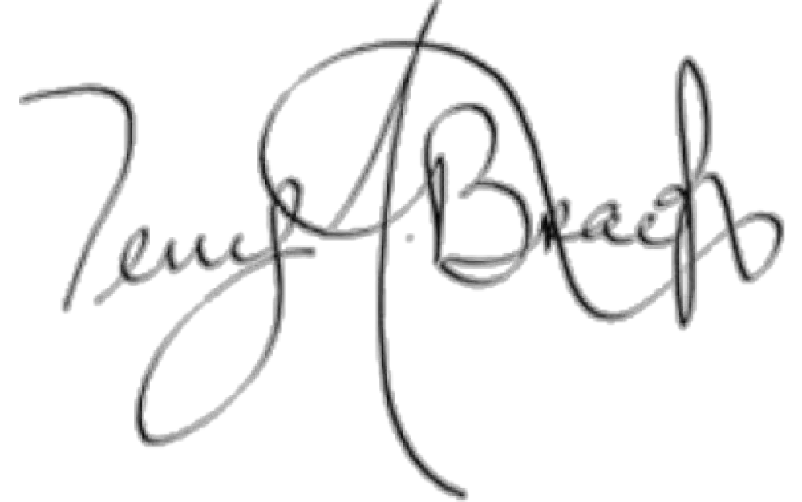CS-C 702.2 Page 2 of 2 (08/21)

**Print Form**

**Save Form**

**Reset Form**